A Poem of Thanksgiving and Abundance
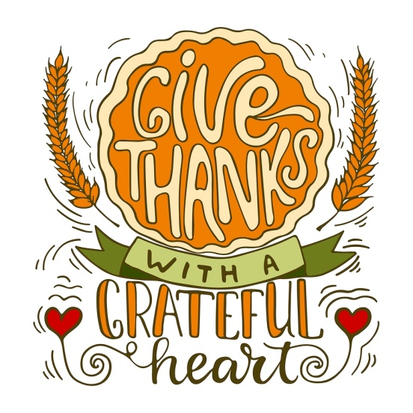
Gather with loved ones 'round a bountiful table
Because it's always the season to be giving and grateful.
We hope you enjoy this Thankfulness rhyme...
Written with love and holiday cheer in mind.

We put the Principles of Prosperity in this poem
(Please forgive us if we're no Leonard Cohen).
It contains a reminder of our 7 golden rules;
Know that we apply them as our own financial tools!

Scarcity cannot exist if eliminated from your mind
So THINK abundant thoughts -- all of the time!
Keep a positive focus, be grateful and affirming
Adopt a growth mindset, and never stop learning.

To have the most efficient personal economy
SEE your whole financial forest, not just individual trees.
Insurance, investments, mortgage and savings--
When they all work together, the momentum's amazing!

Identify your opportunity costs and learn how to MEASURE,
And we'll show you how to build treasure upon treasure!
Keep your cash earning -- even when you borrow against it,
And you will have plenty as you save and invest it.

Everyone strives to build net worth, it seems.
But cash FLOW pays your bills and funds your dreams!
When dollars sit in one place, they grow idle and stagnant;
Put them to use, and become a money magnet!

P4P will show you how to guard and grow your cash
No one cares more than you, so keep CONTROL of your stash!
Don't let the government, market, or broker
Make you a pauper, gambler or joker.

MOVE your money - don't let your dollars sit passive.
After all, nobody wants lazy assets!
And there's one last secret to MULTIPLY your dollars--
Help them do many jobs while you work smarter, not harder!

Use these 7 Principles to guide your financial decisions;
They'll help you progress towards your goals and your visions.
And when you need assistance, you know who to ring;
Questions we'll answer, solutions we'll bring!

We hope you liked our poem, that it made your day lighter;
It's our privilege to help you build a future that's brighter!
We're Thankful to taking this journey with you,
And we wish you Happy Holidays, today and the whole year through!

(Sign the poem - from you and your company/team as appropriate)

