STOLEN SAVINGS: Civil Forfeiture and the Seizure of $446,651

Has Civil Forfeiture Made Banks Unsafe?

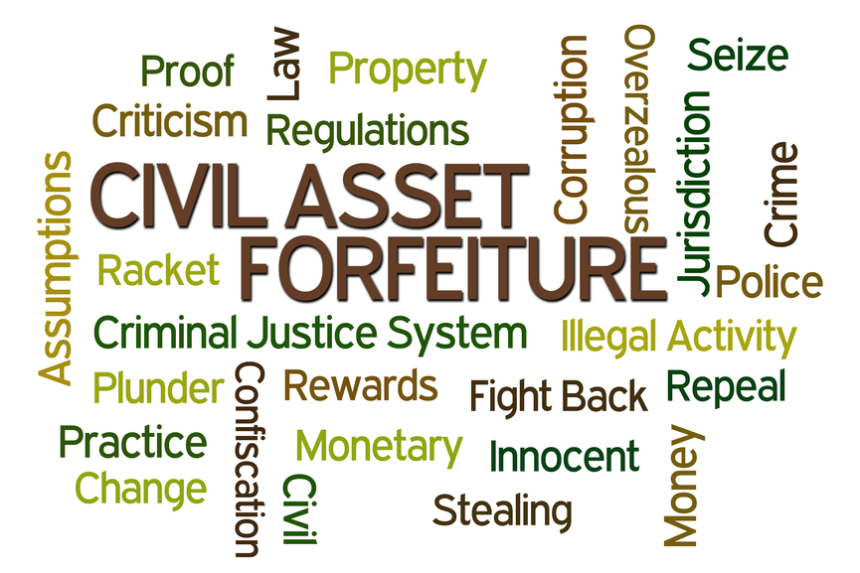
“If you think money you deposit in a bank is yours, think again.”
– DailyPaul.com

Your bank claims to keep your money safe from fraud, theft and harm... but what happens when the criminals are government authorities who can tell banks to freeze or even seize accounts?

That is precisely what Civil Asset Forfeiture Laws allow law enforcement and the IRS to do. Shockingly, money and assets can be taken without convicting or even charging the owner of the money with a crime.

Indeed, civil asset forfeitures have become prevalent precisely because the burden of proof is much lower with civil cases rather than criminal cases. Adding fuel to the fire, those doing the taking usually stand to benefit from the confiscations.

Three Brothers and a Bank Account

Jeff, Mitch and Rich Hirsch have run Bi-County Distributors out of Long Island, New York for over 27 years. They supply candy and snacks for convenience stores in the area. Since most of their customers operate on a cash-only basis, frequent cash deposits are unavoidable.


In 2012, one the brothers thought the teller was joking at first when he went to make such a deposit, only to find out that their account was frozen.

The IRS had seized nearly $447,000, exercising a previously little-known policy known as civil asset forfeiture. An October 24, 2014 article in the New York Times described civil asset forfeiture this way:
"Using a law designed to catch drug traffickers, racketeers and terrorists by tracking their cash, the government has gone after run-of-the-mill business owners and wage earners without so much as an allegation that they have committed serious crimes. The government can take the money without ever filing a criminal complaint, and the owners are left to prove they are innocent. Many give up."
Had the Hirsch brothers committed a crime? No. Were they engaging in tax fraud? No. Had they been charged with a crime? Nope. So why did the IRS seize and drain their account?

As required by the Bank Secrecy Act of 1970, banks and other financial institutions must report cash deposits of over $10,000. The Hirsches had experienced the closure of three accounts due to the paperwork burden of their frequent large cash deposits. Their accountant advised them to keep the deposits under $10,000, which they did for more than a decade.

Unfortunately, cash deposits of under $10,000 can be seen as restructuring or "smurfing," an attempt to avoid the bank reporting the deposits. When a detective noticed their pattern of deposits, it was used as the excuse to seize the Hirsch Brothers’ account.

Although the Hirsch brothers have never been charged with a crime, they were offered a settlement twice, which involved giving up a large amount of their money to receive the remainder. As Jeff Hirsch says, “We weren’t going to take a settlement because I was not guilty.”

An independent forensic accountant hired by the Hirsches reviewed their books actually discovered that the brothers had slightly overpaid their federal taxes. But proof of their innocence did not cause their money to be returned, nor were they even allowed to present their evidence in a court of law.

Unfortunately, the story of the three brothers and a bank account is not an isolated incident. Ask Sergeant Cortazzo, who was only able to recover part of his daughter's college fund, or grandmother Carol Hinders, who spent over twice her stolen $33k in legal fees to recover the money seized from her account. And in the bizarre case of Kerry Kaley, even the $500k line of credit she took from her house to defend herself when she was allegedly accused of stealing medical equipment was then frozen by the federal prosecutor.

Civil Asset Forfeiture: "Like Pennies From Heaven"


Civil asset forfeiture isn’t limited to bank accounts, nor is it limited to the IRS. Local and state law enforcement have their own forfeiture machinery, and often they collaborate with federal authorities, including the DEA, FBI and IRS. Cash, cars, boats, and houses are seized every year from many thousands of citizens, often without a formal accusation of wrongdoing.

The 80% rule. In cases requiring the cooperation of federal and local law enforcement, the "Equitable Sharing" program provided for in the Comprehensive Crime Control Act of 1984 allows local agencies to retain up to 80% of the proceeds from confiscations. And, according to a study done by a former Congressman and the Cato Institute, an estimated 80% of those who have their assets seized are never charged with a crime of any kind.

But guilt is not the point, apparently. As comedian-with-a-cause John Oliver's expose on asset forfeiture points out, the money shaken from the pockets of innocent Americans translates into spending sprees for law enforcement agencies. Confessed one sheepishly honest officer, as captured on a police review board video, "We usually base it on something that would be nice to have that we can't get in the budget... It's kind of like pennies from heaven, that get you a toy that you need."

The most common purchases are weapons and vehicles, such as grenades, rifles, and armored vehicles. Confiscated assets have also been used for electronic surveillance equipment, conference tickets, a $5 million dollar helicopter, a Zamboni (an ice resurfacing machine commonly used in ice rinks), and kegs of beer, bottles of Crown Royal, and a margarita machine for office parties. (Talk about a "slush" fund!) Quite commonly, profits pay for a portion of the salaries of the detectives and prosecutors who go after the assets, creating a "need" for the funds.

In Philadelphia, civil forfeiture has turned into a well-oiled profiteering machine. According to data collected by the Institute for Justice, between 2002 and 2012, the Philadelphia District Attorney’s Office seized over 3,000 vehicles, nearly 1,200 homes and other real estate properties and a whopping $44 million in cash.

If those numbers seem shocking, Philadelphia's District Attorney, R. Seth Williams, put them in startling perspective in a March 1, 2015 Philly.com op-ed, noting that asset forfeiture "is used far more extensively by the feds than by local officials. In 2012... the Justice Department seized almost $9 billion worth of property in civil, noncriminal proceedings. That's nine billion, with a B - or about 1,800 times more than the value of all the property seized that year in Philadelphia."

Nine billion is a LOT of cash and property - especially if those being deprived of it do not have to be convicted of crimes in order to lose it.

In the skewed logic of civil forfeitures, rather than "innocent until proven guilty," the money or asset itself is seen as the guilty party, and its former owner must prove that it was not used - or intended to be used - in a crime. It is rarely practical to fight the forfeiture, as there is no assumption of innocence or provision for a public defender (because there is rarely a formal accusation of a crime).

According to former federal prosecutor David Smith, now a forfeiture expert and lawyer in Virginia, “They’re going after people who are really not criminals, middle-class citizens who have never had any trouble with the law.”

The Missing Money and the New Attorney General

In early 2015, the Hirsch brothers' case was finally resolved.

The good news: they got their money back.

The bad news: they cannot seek reimbursement for tens of thousands in legal fees and other costs. The feds who seized the nearly $447k from their business bank account were cleared of all wrongdoing and liability as a condition of the return of their money.

The bizarre news is the reason WHY the money was suddenly released back to them after their nearly three-year battle. It turns out that Loretta Lynch, our new U.S. Attorney General, headed up the office that oversaw the Hirsch case from 2012 until 2015. For over two-and-a-half years, Lynch's office did all it could to block the return of the Hirsches' funds. Then the brothers took their story to the press.

Shortly afterwards, Lynch was nominated for the position of Attorney General. As Lynch's confirmation hearing neared, it appeared that the case and the negative press it had attracted could be problematic.

Exactly one week before Lynch was to go before a congressional committee, the funds were returned. The office of the federal attorney for the Eastern District of New York drew up the settlement, releasing the Hirsch brothers' money on the condition that the office was released of all liability. LINK TO CIVIL-ASSET-FORFEITURE-LYNCH File

According to Robert Everett Johnson, one of the attorneys that represented the Hirsch brothers in their battle to reclaim their money, Lynch's office had ignored the Civil Asset Forfeiture Reform Act and asserted a right to hold property for up to five years without giving the owners a hearing before a judge. "The result is a practice that looks a lot like extortion. Rather than prove their case to a judge, prosecutors from Lynch's office demanded that the brothers sign over a hefty portion of their bank account to the government in order to get back the remainder."

Civil Forfeiture Reform is Lacking

Only a few days before the settlement was reached, then-current U.S. Attorney General, Eric Holder announced changes were being made to limit civil asset forfeiture. A new policy would stop the process of "adoption," in which state and local officials use federal law to easily seize assets without charging owners with a crime. Many were thrilled that Holder seemed to be effectively ending forfeiture abuses.

But perhaps the celebration was premature. The Institute for Justice, a law firm which has led the fight against civil forfeiture, notes significant loopholes in the new policy. It still allows forfeiture through joint task forces and joint investigations. Additionally, the federal government can still pursue its own civil forfeiture actions. And according to the Institute, "The policy does not change state forfeiture laws, many of which burden property owners and permit policing for profit."

We hope that significant changes are on the way, but there is much evidence to suggest that civil forfeiture will continue, just with a few additional restrictions. The Wall Street Journal, notes the Attorney General's track record demonstrates she is "an enthusiastic grabber of private assets," having used civil asset forfeiture in more than 120 cases to take in $113 million for federal and local coffers.

New IRS regulations have also been passed to protect innocent people, yet abuses remain. Lyndon McLelland, a hard-working North Carolina convenience store owner with a 10th grade education lost over $107k when it was seized by the IRS. He was never accused of a crime, however, in early 2015, his attorney received an offer from the prosecuting attorney to return only 50% of the money.

Pls post/ imbed video: https://www.youtube.com/watch?v=uGtFWC-12-w

Where Is Your Money Safe?

As disturbing as these stories are, perhaps there are lessons that can be learned. Surely the first is, "watch where you put your cash!" Fortunately, there are safer places to save than a bank.

Two of the many reasons we recommend high cash value whole life policies are SAFETY and PRIVACY.
- Funds in cash value accounts are typically shielded from the prying eyes of the IRS, "detectives" or government authorities looking for assets.
- These accounts do not involve 1099s and are not taxable, as long as dollars remain in the policy.
- In many states, cash held in insurance policies is protected from creditors, lawsuits and judgments.
- Insurance policies are not considered assets reportable on the FAFSA, which determines financial aid for college students.
- Life insurance companies are not allowed to leverage like banks, so the cash value is backed up by real assets.
- Additionally, the long-term rates of return greatly exceed savings account returns, making funds safe from inflation as well.

If you want to find out more about high cash value policies, consult your Prosperity Economics Advisor. If you don't have an advisor who is familiar with Prosperity Economics strategies, contact us and we will help you find one.

©Prosperity Economics Movement

Jeune - the pic of the 3 brothers, please use this caption: "The Hirsch Brother of Long Island. (Photo courtesy: The Institute of Justice)"

CATEGORIES: Financial trends, savings, whole life insurance

tags: civil forfeiture, civil asset forfeiture, long island civil forfeiture, IRS bank forfeiture, bank safety

Keyword: Civil-forfeiture

URL: ProsperityPeaks.com/stolen-savings-civil-forfeiture-banks-unsafe

