Are Bonds Still a Good Choice for Safe, Steady Growth?
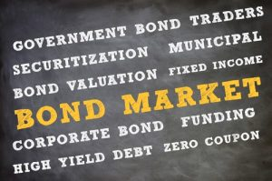
If you’ve been paying attention, you’ll know that bonds aren’t what they used to be. Values are declining, risk is up, investors are selling, bond funds are underperforming, and municipal bonds are no longer the safe haven they once were.
“With the demise of the bond insurance industry in the financial crisis, credit quality in the market has become a much bigger concern for investors,” reported financial journalist Andrew Osterland on February 28, 2018 for CNBC.com. Earlier in the year, Financial Times noted sell-offs and declared that “the long bond rally could stall—and perhaps even unravel—in 2018.” This week, Bloomberg.com noted “concerns over volatility” in high-yield bonds. Even Kiplinger.com, which typically faithfully tows the line of “typical” financial advice, had harsh words for bonds in a December 2017 article:
The outlook for the bond market is bleak. With the benchmark 10-year Treasury yielding a paltry 2.36%, it’s simply not worth the risk to own it. Should market rates rise just one percentage point, the price of that 10-year bond would fall about 9%.”
While we tend to think of rising interest rates as a good thing for fixed income instruments, bond prices move in the opposite direction as interest rates. Additionally, a bond mutual fund can lose value when the bond manager sells bonds in a rising interest rate environment, while investors in the open market demand a discount on the older bonds that pay lower interest rates. And of course, when bond issuers default, bond values plummet.
Unfortunately, some investors mistakenly believe that bonds can’t or won’t lose money. But as Kent Thune explained in a December 2017 article on TheBalance.com, it is a “common misconception among beginning investors is that ‘bond mutual funds are safe.’”
During the 2008 stock crash, instead of protecting municipal bond investors, Bloomberg Barclays Municipal Index lost nearly 2.5% in 2008 during the stock crash. “That’s hardly catastrophic, but it might not have represented the resilience that the bond investors were expecting,” notes Morningstar analyst John Coumarianos, before making an ominous prediction that “results might be less benign during the stock market’s next wipeout.”
Municipal bonds have indeed become increasingly unpredictable in recent years. In January of 2018, the Wall Street Journal announced, “Muni Bonds May Not Be the Reliable Bet They Once Were,” advising investors to “understand the risks” and “adjust their strategy accordingly.” The asset class has fundamentally changed since the Financial Crisis, as an increasing number of cities, states, and now Puerto Rico have defaulted on obligations. Furthermore, when municipalities go bankrupt, bondholders must wait in line behind employee pension funds for payment.

“The Worst January Since 1981”
Even diversified muni-bond funds have suffered. “January is usually a stellar month for the municipal bond market. Not this year.” Citing a 1.18% loss for the month in the Bloomberg Barclays Municipal Bond Index, Osterland notes it was “the worst January for municipal bonds since 1981.” Since January, the fund has continued its decline, posting a year-to-date loss of 1.65% on April 24.
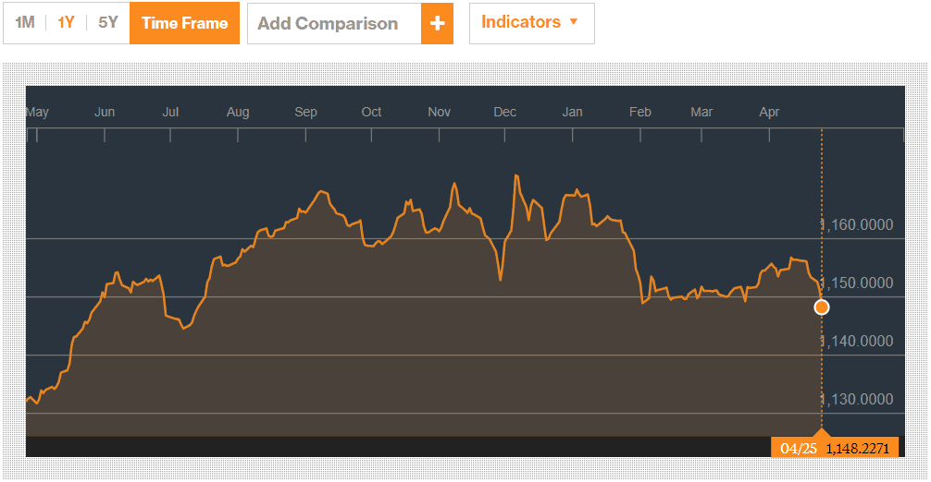
Add rising interest rates to the mix and lowered corporate taxes, which decrease incentives for muni-bonds, and we could be in for worsening woes.
“Interest rates have hurt the market,” Tom Hession, managing partner of Riverbend Capital Advisors told CNBC.com regarding municipal bonds. “People see rates going up and they sell.” Hession adds a backhanded recommendation: “Yields are more attractive than they’ve been in a long time, so if someone is comfortable with a more volatile environment, this could be a good time to consider municipal bonds.”
Meanwhile, Kiplinger columnist Steven Goldberg warns “income-hungry retirees” against reaching for higher yields from troubled companies. He argues that the purpose of bonds is not to earn income, rather, to decrease the volatility in your overall portfolio. But can we rely on bonds for steady gains? Perhaps not.
Goldberg goes on to halfheartedly recommend four bond funds which he sees as the best of a weak, unreliable asset class. Two receive this depressing warning: “Don’t expect either of the Vanguard funds to return more than 1% or 2% annually anytime soon.” One receives an additional warning that “you’d expect to lose roughly 2.6% if rates were to rise one percentage point.” The other two funds may return a bit more, Goldberg says, adding that they are “quite a bit riskier,” investing in things such as so-called “junk” bonds and emerging market debt.
So much for bonds as the “safe,” steadily-gaining part of your portfolio!
While bond funds are generally less risky than stock market funds, with more moderated losses as well as profits, investors relying on bonds to provide gains if (or when) stocks fall could be in for disappointment.

Seeking bond alternatives
So if not bonds, then what? It depends on what you were trying to get out of bonds.
If you were invested in muni-bonds primarily for income, we think there are other options worth considering. Private lending—the oldest form of investment around—is alive and well. Private equity funds, bridge loans, land leases, fractional real estate investments and other opportunities can generate regular monthly income. Depending on your situation, immediate annuities might be a good choice.
If you were looking to bonds for long-term safety and stability and reliable tax-advantaged growth, you should give serious consideration to high cash value whole life insurance. Dividend earnings rates vary according to age, health, and insurer, but net policy gains for cash value after costs are currently in the 2-4% range for many policy owners, when held long-term. (This does not include an additional death benefit paid to beneficiaries.) When adjusting for the preferential tax treatment (tax-deferred, often tax-free gains as long as the policy remains in force), you’d have to earn upwards of 4 or 5% to match the gains of whole life insurance.
While a rate of 5% is certainly doable in many investments, consider the quality of the asset when it comes to life insurance. It is not an equity that will roller coaster ride, but a time-tested vehicle with guaranteed minimums. Dividends have been faithfully paid for well over 100 years through every economy, and gains are locked in. Furthermore, industry requirements for reserves make life insurance one of the safest places to store cash… certainly safer than muni-bonds in today’s market!
And if you simply want short-term place to store cash you’ll need a year or two from now, you’re likely better off with an internet bank savings account. Banks such as Discover, Ally, and Marcus are all paying around 1.5% at this writing, with no monthly fees. CDs can pay a smidge more if it’s worth it to you to sacrifice liquidity.
What we DON’T recommend you do is simply give up on “safe money” and rely on a portfolio of nothing but mutual funds and ETFs. That’s setting yourself up for failure without a safety net.

Is it time to explore alternative ways of saving and investing?
Prosperity Economics shows you how to create wealth outside of Wall Street and the big banks! To find out more about stock, bond, and cash alternatives, contact us today!

©ProsperityEconomicsMovement

